4. Requirement Engineering
So this portion basically explains how we collected the requirements for our System , how we analysed them, and what the final specification looked like before the design started.

4.1 Requirement Collection
We collected requirements in three ways: an online survey, semi-structured interviews, and a comparison of existing tools. The survey went to people who do both individual and team work, such as students, freelancers, contractors and people in creative jobs. The interviews were done with four people from one small startup: the founder, a project lead, a senior engineer and a freelance contractor. They all see the same project from a different side, so we got very different answers. We also studied Trello and Asana to see what is already available in the market and what is missing from it.
Requirement collection methods
Method | Who was involved | What it gave us
Online survey | Students, freelancers, contractors and creative workers who do individual and team work | General pain points and which features matter most to users
Semi-structured interviews | Four people from one small startup: founder, project lead, senior engineer, freelance contractor | Detailed problems and concrete feature ideas, with real examples
Comparison of existing systems | Trello and Asana (feature and technology review) | What current tools do well and the gaps our system should fill

The interviews gave us the most useful information. For example, the freelancer explained that the deadline clock keeps running even while he waits for the client to approve his work, which feels unfair to him. This is where the idea of a "waiting on approval" status that pauses the timer came from. The senior engineer said she keeps a private list of only her own tickets and blockers because the team board is too noisy, which became the reason for building a personal dashboard. The lead wanted to see progress without asking people in meetings, which led to the analytics and workload views. Overall, the main things we found were:
- Users need a personal workspace next to the shared project space.
- Task management must support dependencies, deadlines and progress, not just simple lists.
- Work hours and progress should be connected to the actual task being done.
- Collaboration needs comments, notifications and controlled access, especially for contractors.

4.2 Requirement Analysis
After collection, we grouped everything into five problem domains so related issues stay together:
- User identity and access management - login, roles and what contractors are allowed to see.
- Task lifecycle and context aggregation - one place where the brief, files, discussion and status of a task live together.
- Dependency and dynamic timeline engine - tasks that block other tasks, and deadlines that react when an earlier task is delayed.
- Workload capacity and effort tracking - who is busy, who is free, and estimated hours against real hours.
- Analytics and performance metrics engine - simple charts that turn work records into evidence of performance.
We then checked these domains against Trello and Asana. Simple boards, comments and attachments already work well there, so we kept those ideas instead of reinventing them. But native time tracking, task dependencies and personal analytics are missing or need extra plugins, so these became our main focus areas.
Finally we prioritised with a simple MoSCoW approach. Must have: accounts and roles, projects, tasks with statuses and checklists, dependencies, time logging, comments and attachments. Should have: notifications and the personal analytics dashboard. Could have later: automatic integrations with tools like GitHub or Figma and fully passive time tracking.

4.3 Final Specification
The final specification is written functional and non-functional requirements. These requirements were used as a guide for the design and testing sections, so it was easier to check that the main requirements were covered throughout the project.

Final functional requirements
Requirement | Source
Users can register and log in with email and password. | Basic / interviews
Each project has members with the role LEAD, ENGINEER or CONTRACTOR. | Questionnaries
A lead can create projects with a start date and deadline and add members to them. | All groups
Users can create tasks with title, description, priority, dates and estimated hours, and assign them. | Questionnaries
Tasks have a checklist that works as the definition of done. | Questionnaries
Tasks move through todo, in_progress, waiting_approval and done; the deadline timer is frozen while waiting for approval. | Questionnaries
Users can set dependencies between tasks; when a blocking task is done, the blocked assignee is notified. | Questionnaries
Users can comment on tasks and attach files to them. | Questionnaries
Users can log work time (start, end, duration) for each task. | Questionnaries
Each user gets a personal dashboard with their active tasks, blockers and progress. | Questionnaries
The system shows analytics such as logged vs estimated hours, completion rate and on-time delivery. | Questionnaries
The system sends notifications for assignments, blockers, unblocking and approval requests. | Questionnaries

Final non-functional requirements
Requirement | Source
Passwords are stored as hashes and contractors can only see the projects they are members of. | Questionnaries
Updating a task status takes only a few clicks, with no duplicated manual reporting. | Questionnaries
No invasive monitoring: no screenshots, no keystroke tracking and no ranking badges. | Questionnaries
The database enforces valid data, such as date order, non-negative hours and completion consistency. | Design decision
The system works for a single user and scales up to small teams with several projects. | Problem statement
Main pages such as the dashboard and task list stay fast as data grows. | General

5. System Design
Based on the specification, we designed WPMS being as a three-layer web application. The browser client uses a Node.js backend over a REST API with JSON, and the backend goes through a MySQL database. First Figure shows this architecture together with the main services of the backend.
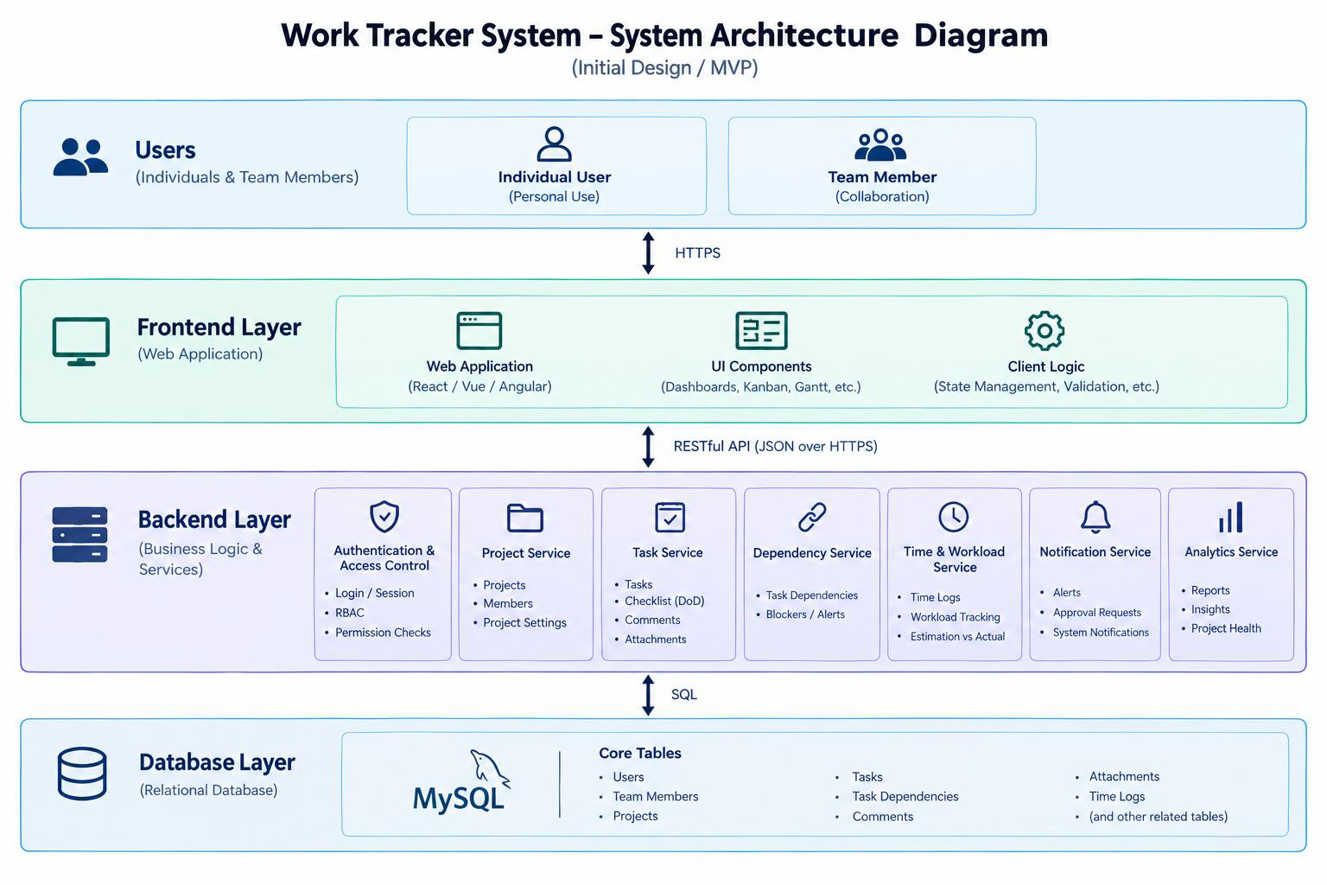
Figure 1: System architecture diagram of WPMS

5.1 Database Design
We chose MySQL with the InnoDB engine because the data is strongly related and we wanted real foreign keys and check constraints. The entity relationship diagram in following figure shows the nine core tables and how they connected.
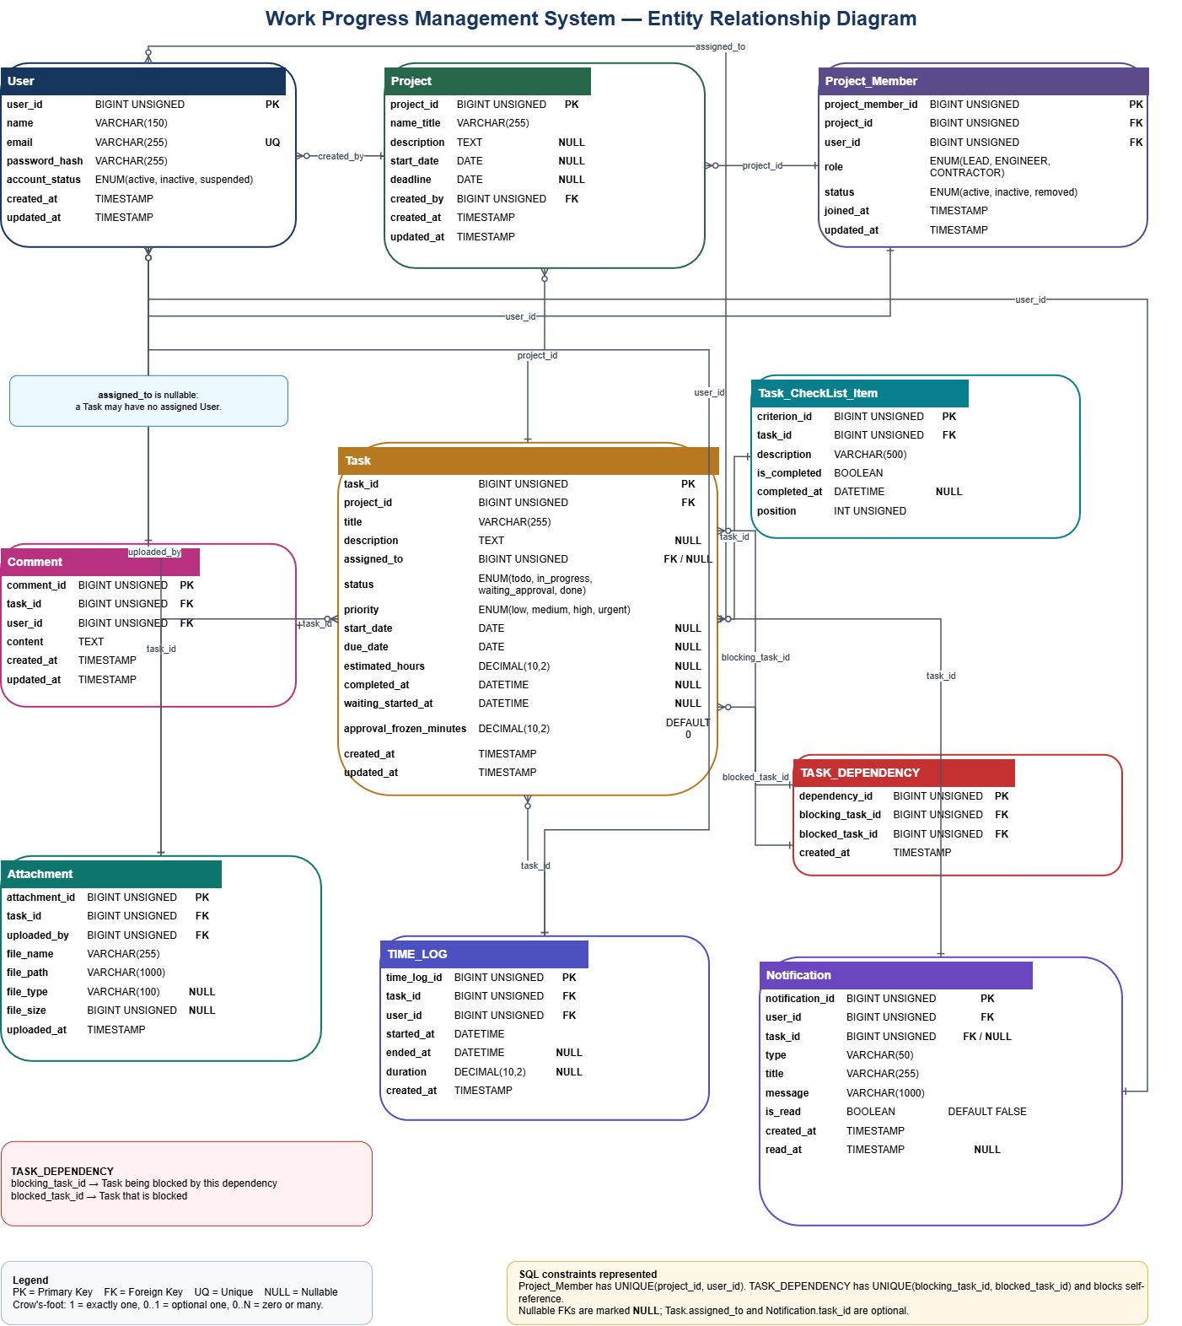
Entity relationship diagram of the database
Database tables and their purpose
Table | Purpose
User | Accounts and login information; stores the password hash, not the password.
Project | Project name, description, start date and deadline, and who created it.
Project_Member | Which user is in which project with which role (LEAD, ENGINEER, CONTRACTOR). One row per project-user pair.
Task | The main work item: status, priority, dates, estimated hours and the assigned user.
Comment | Discussion attached to a task.
Task_CheckList_Item | Acceptance criteria (definition of done) of a task, with an order position.
TASK_DEPENDENCY | Which task blocks which task; a task cannot block itself.
Attachment | Files uploaded to a task, with name, path, type and size.
TIME_LOG | Start, end and duration of work sessions on a task.

Some design decisions in the schema are worth mentioning:
- A task can exist before it is assigned, so assigned_to is nullable if a user is deleted, their tasks stay with assigned_to set to NULL.
- Deleting a project also deletes its tasks, comments and logs (CASCADE), but comments and time logs protect their author with RESTRICT so history is not lost by accident.
- Project_Member has a UNIQUE constraint on (project, user), so one person cannot hold two roles in the same project.
- CHECK constraints keep the data sensible: the due date cannot be before the start date, hours cannot be negative, and completed_at is only filled when the task is done.
- Indexes on status, priority, due date and all foreign keys keep the board and dashboard queries fast.

5.2 Interface Design
Before coding, we mocked up the five main screens. All pages share the same simple style: a dark blue navigation bar on top, white cards on a light background, and one clear action per card so the pages stay easy to read.
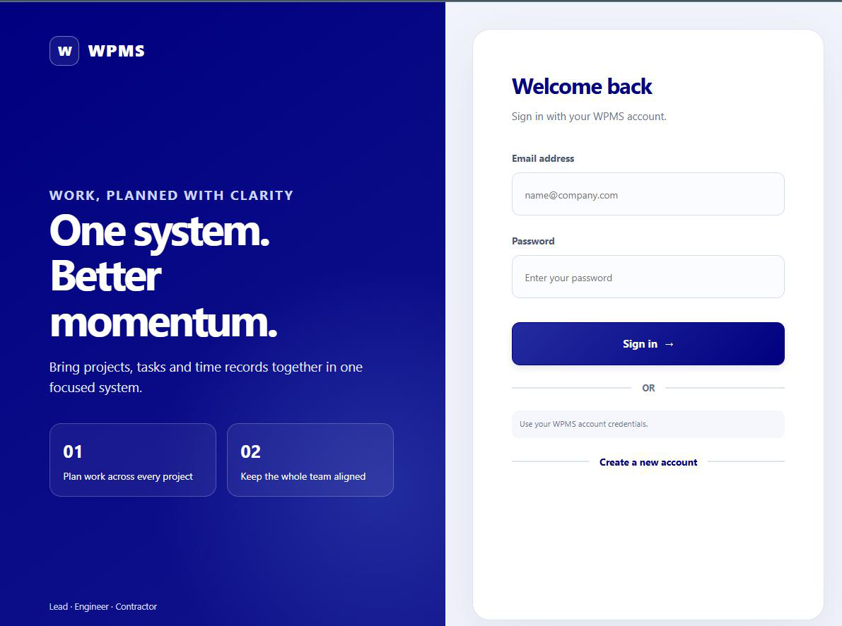
Login page mockup
The login page uses a split layout: the left side explains the system and the right side has the sign-in form, with a link to create a new account.
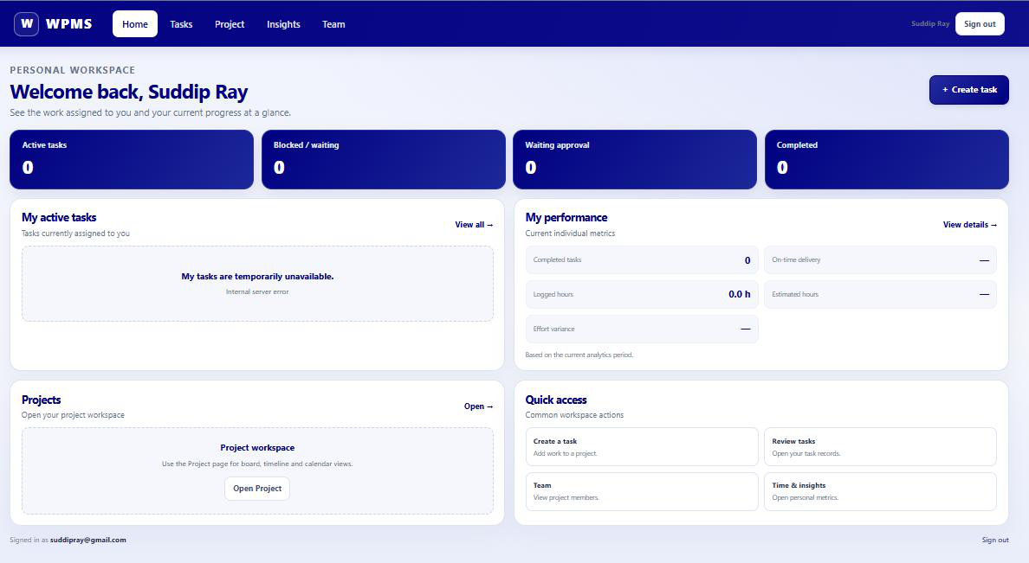
Figure 4: Home dashboard mockup
The home page is the personal workspace. It shows four counters (active, blocked, waiting approval and completed), the user's active tasks, their personal performance and quick access links to the other pages.
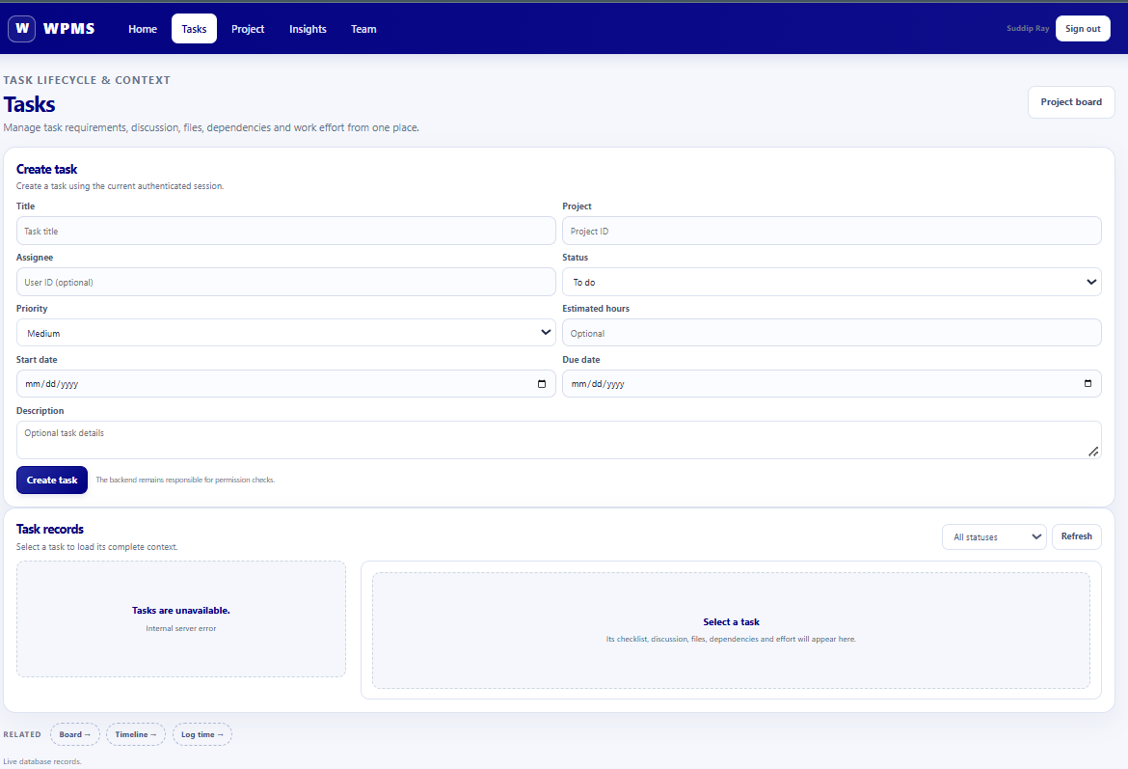
Tasks page mockup
The tasks page has a create-task form with all fields from FR04, and below it the task records. Selecting a task loads its full context: checklist, discussion, files, dependencies and effort.
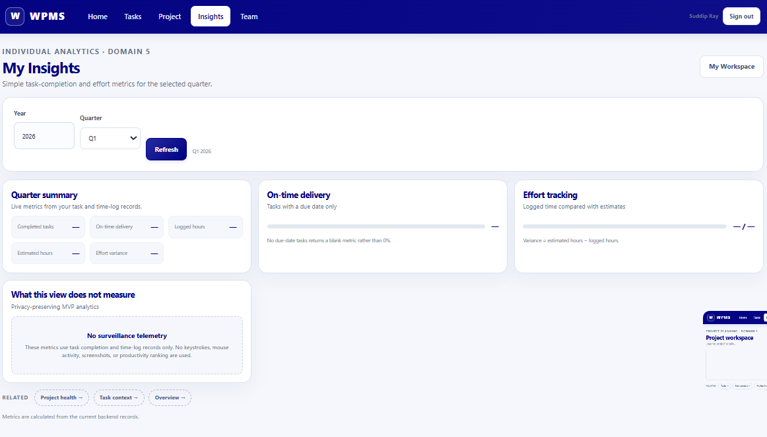
Insights (analytics) page mockup
The insights page shows the quarterly summary: completed tasks, on-time delivery and logged versus estimated hours. It also states clearly what it does not measure, to respect NFR03 (no invasive tracking).
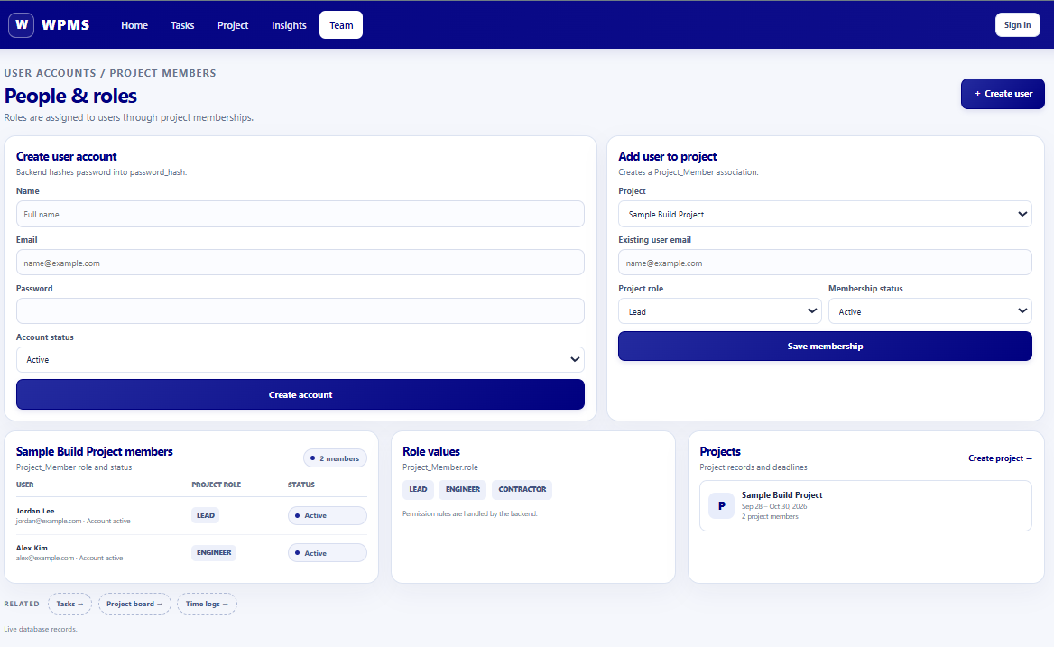
People and roles (project contributors) page mockup
The team page lets a lead create user accounts, add users to a project with a role and see the current members.

5.3 System Navigation Design
The use case diagram in Figure 8 shows who can do what in the system. Employee, Contractor and Project Lead share the basic use cases such as logging in, updating task status, commenting, attaching files and receiving notifications. Only the lead can create projects, create and assign tasks, manage contractor access and open the performance and Gantt views, which matches the access control requirement .
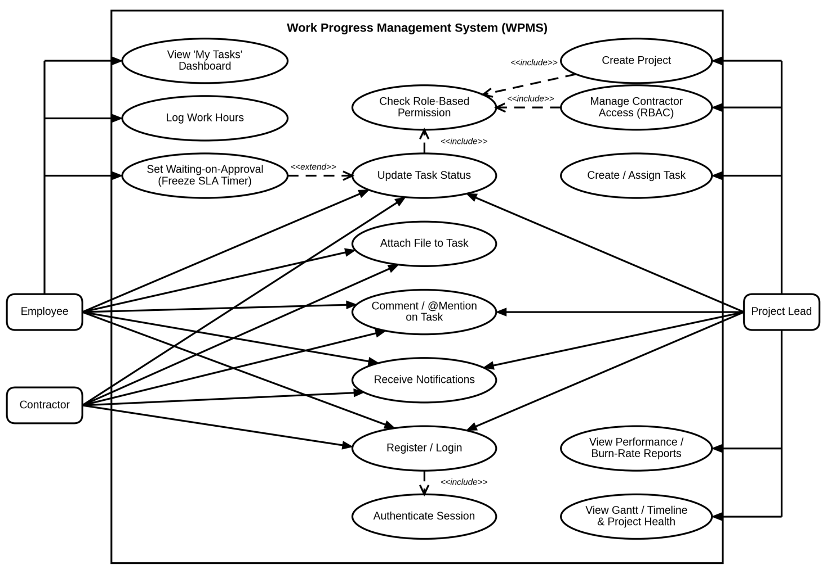
Use case diagram of WPMS
Following figure shows the main activity flow of a task. The lead creates the task with a definition of done and assigns it. The assignee works on it and ticks the checklist items. When all items are checked, the task moves to waiting approval and the SLA timer is frozen while the lead is notified. If the lead approves, the task becomes done, any blocked downstream tasks are unblocked and the hours are finalised for the burn-rate calculation. If not, the task goes back to in progress with feedback.
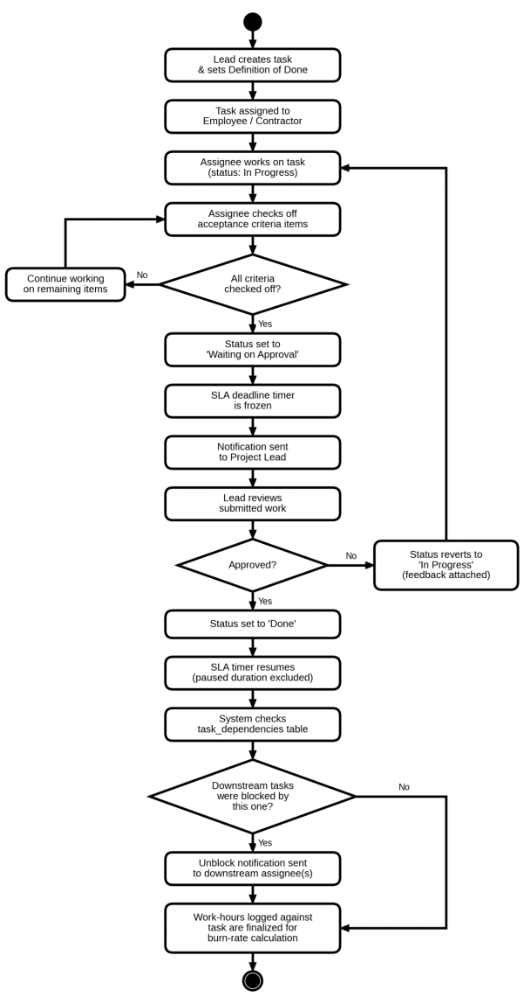
Activity diagram of the task lifecycle
Next figure is the screen map of the system. After login the user always lands on the home dashboard, and from there the top navigation bar reaches every page in one click. The Tasks page opens the full task context, the Project page switches between the Kanban board and the Gantt timeline, Insights shows the charts and Team manages members and roles. Together, these diagrams were the blueprint we followed in the implementation chapter.
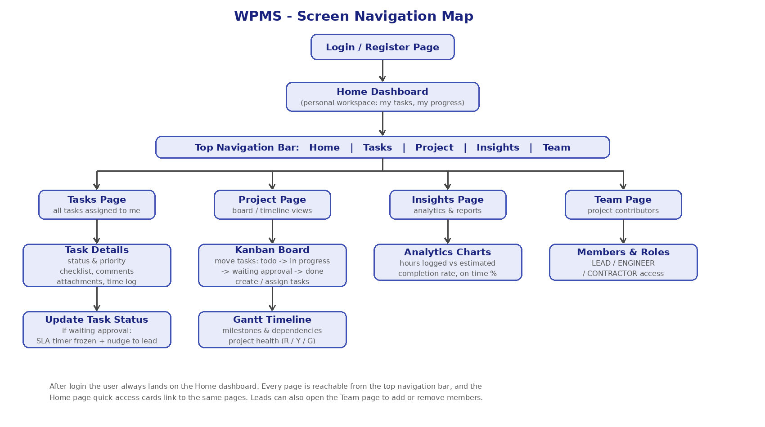
Screen navigation map of WPMS

